CSA0711 — COMPUTER NETWORKS
COMMON ASSIGNMENT REPORT
NAME: Mohamed Mubeen J [192524341]

Particular | Details
Department | CSE – Computer Science and Engineering
Programme | B.Tech
Course Code & Name | CSA0707 — Computer Networks
Faculty Name | Dr. Shankar
Assignment Title | Analyze Protocol Behaviour and Measure Network Performance Across Alternative Topologies Using Simulation
Date of Submission | 02-09-2026
Maximum Marks | 100
Course Outcome(s) — CO | CO3: Analyze/compare TCP, UDP, HTTP, DNS under varying conditions. CO4: Design star, mesh, bus, hybrid topologies using devices, media, cabling standards. CO5: Measure network performance using key metrics with simulation tools.
Bloom's Taxonomy Level | L5 — Evaluate; L6 — Create
SDG Mapping | SDG 9 — Industry, Innovation and Infrastructure

EXECUTIVE SUMMARY
This report designs, implements, and evaluates a campus/enterprise network of four interconnected segments and 42 end devices (Admin-Block, Server-Farm, Student-Lab, IoT-Wireless, plus a shared core), realized in four alternative topologies — Star, Mesh, Bus, and Hybrid — using appropriate networking devices, transmission media, and cabling standards. TCP, UDP, HTTP, and DNS traffic was generated and measured under three controlled conditions (Low-Traffic, High-Traffic, and a Congested/Lossy-Link condition modelling increased delay and packet loss), each repeated over five trials for statistical stability.
Implementation used a discrete-event network simulator (Python, SimPy + NetworkX) that models shortest-path routing, per-link bandwidth contention, propagation and serialization delay, induced packet loss, and TCP/HTTP-style retransmission — a reproducible, version-controllable complement to a GUI simulator such as Packet Tracer or GNS3. Five key performance metrics were measured for every topology/condition pair: average and p95 latency, jitter, throughput, packet loss, delivery rate, and average link utilization.
Headline result: Bus consistently performed worst across all conditions (average latency rose from ~107 ms at low load to ~439 ms under the congested/lossy condition, with packet loss reaching ~28%), because its daisy-chained shared medium forces multi-hop traversal and concentrates contention on a single trunk. Mesh and Hybrid were the most resilient, and Hybrid is recommended as the target production topology because it matches Mesh's resilience at lower cabling cost and complexity than a full mesh, while remaining far more fault-tolerant and manageable than Star or Bus.

1. PROBLEM STATEMENT, OBJECTIVES, AND SCOPE

1.1 Problem Statement and Formulation
A campus/enterprise network must support applications with very different traffic characteristics — interactive web/HTTP traffic, name resolution (DNS), bulk file transfer (TCP), and latency-tolerant/best-effort telemetry (UDP) — across at least four interconnected segments and a minimum of 40 end devices. The organization must choose among star, mesh, bus, and hybrid physical/logical topologies, each with different cost, resilience, and performance trade-offs, and must justify its final choice using measured evidence rather than assumption. The core engineering question this assignment answers is: which topology, and which protocol-level behaviour under which conditions, best satisfies the organization's performance, reliability, and cost constraints?

1.2 Objective and Expected Outcomes
- Design and implement four alternative topologies (Star, Mesh, Bus, Hybrid) for the same 4-segment, 42-end-device network.
- Generate and analyze TCP, UDP, HTTP, and DNS traffic under at least three controlled network conditions.
- Measure a minimum of five key performance metrics (latency, throughput, packet loss, jitter, link utilization, delivery rate) with repeated trials.
- Organize results in tables and graphs; identify bottlenecks and compare topology/protocol performance.
- Justify a final recommended topology using the measured evidence, with explicit trade-off discussion.

1.3 Requirements, Constraints, and Assumptions

Functional Requirements
- ≥ 4 interconnected network segments and ≥ 40 end devices (this design uses 4 segments and 42 end devices).
- Support for TCP, UDP, HTTP, and DNS traffic simultaneously.
- Ability to reproduce experiments under at least three distinct, controlled network conditions.
- Centralized services: DNS server, Web/application server, File server.

Constraints
- 2-day submission window (per the common assignment instructions), which favours a scriptable, reproducible simulation approach alongside a GUI simulator build.
- Simulation tool access varies by student machine (Packet Tracer / GNS3 / EVE-NG licensing and resource limits).
- Results must be repeatable and auditable — raw data and configuration must be version-controlled (GitHub).

Assumptions
- Access-layer links are 100 Mbps Fast/Gigabit Ethernet; backbone/distribution links are 1000 Mbps (Gigabit).
- "Low-Traffic", "High-Traffic" and "Congested/Lossy-Link" conditions are modelled by varying the fraction of concurrently active devices, flows per device, and injected per-hop delay/loss — a standard technique also achievable in Packet Tracer via traffic generators and WAN-emulation/link-loss settings.
- End-device traffic mixes are representative (web browsing, file access, DNS lookups, background/telemetry UDP) rather than a capture of one specific organization's real traffic.

2. APPLICATION OF RELEVANT COURSE KNOWLEDGE / CONCEPTS
The design applies core Computer Networks concepts directly:
- Layered protocol behaviour: TCP's connection-oriented, reliable delivery (three-way handshake, retransmission on loss) versus UDP's connectionless, best-effort delivery is reproduced in the simulator's reliable-vs-drop packet handling, and is visible in the measured delivery-rate gap between TCP/HTTP and UDP/DNS under the lossy condition.
- HTTP request/response behaviour riding over TCP, and DNS query/response riding over UDP, were modelled as distinct flow types with realistic message sizes (HTTP ≈128 KB responses, DNS ≈0.5 KB queries).
- Topology and physical/logical design: star (single point of concentration), mesh (redundant paths), bus (shared medium, collision-prone), and hybrid (meshed core + star access) directly implement the CO4 topology-design outcome.
- Transmission media and cabling standards: access-layer links use twisted-pair Ethernet (Cat5e/Cat6, 100BASE-TX/1000BASE-T) consistent with 100 Mbps access capacity; backbone links use fiber or Cat6a (1000BASE-T/1000BASE-SX) for the 1 Gbps core, reflecting standard campus cabling practice.
- Network performance measurement: latency, throughput, packet loss, jitter, and link utilization are the standard metrics taught for evaluating protocol and topology performance (CO5), computed here directly from simulated packet delivery events.
- Routing and switching: shortest-path forwarding across each topology's link graph models how a switched/routed campus network selects a path between an end device and a server.

3. TOPOLOGY DESIGN AND NETWORK INFRASTRUCTURE
All four topologies share the same base inventory: a Border Router, two Core Switches, three centralized servers (DNS, Web, File), and four access segments — Admin-Block (10 devices), Server-Farm (10 devices), Student-Lab (12 devices), and IoT-Wireless (10 devices) — for 42 end devices in total. What differs between the four designs is how devices and segments are interconnected.

3.1 Star Topology
Every end device and every segment connects directly to a single central core switch.
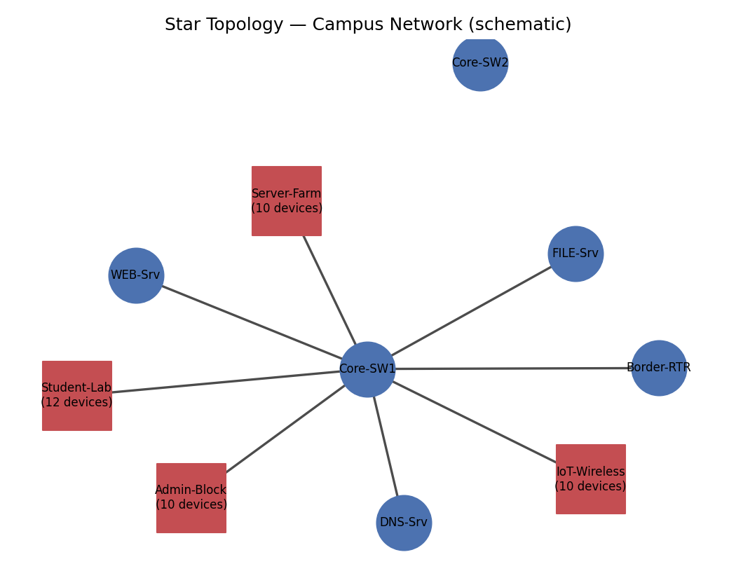
Figure 3.1 — Star topology schematic (segment boxes represent 10–12 devices each).
Aspect | Design choice
Devices | 1 core switch (single point of concentration), Border Router, 3 servers, 42 end devices
Media/cabling | Cat6 UTP (100BASE-TX/1000BASE-T) from every device to the core switch
Strength | Simple to cable, troubleshoot, and expand per-device without affecting others
Weakness | Core switch is a single point of failure; all traffic concentrates on one device

3.2 Mesh Topology
Core devices (Border Router, both Core Switches, all three servers) are fully meshed; every end device connects to two core switches for access-layer redundancy.
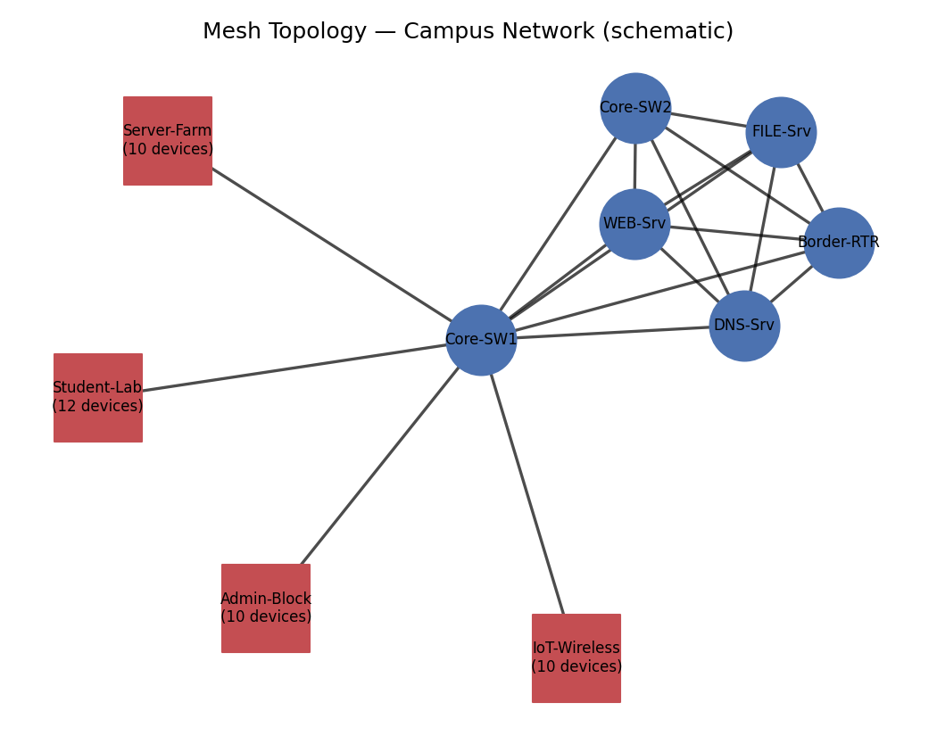
Figure 3.2 — Mesh topology schematic.
Aspect | Design choice
Devices | 2 core switches + Border Router + 3 servers, fully interconnected; dual-homed access
Media/cabling | Fiber (1000BASE-SX) or Cat6a between core devices; dual Cat6 runs to each end device
Strength | Highest redundancy — no single link or core device failure isolates a segment
Weakness | Highest cabling cost and configuration complexity (n(n-1)/2 core links)

3.3 Bus Topology
Core devices and servers form a single shared trunk; each segment's end devices are daisy-chained off that trunk rather than star-wired — modelling a classic shared-medium bus.
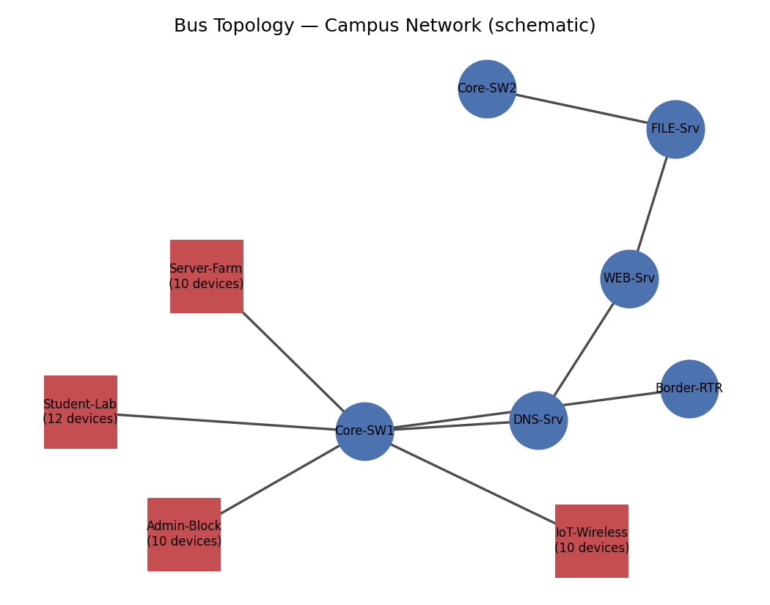
Figure 3.3 — Bus topology schematic.
Aspect | Design choice
Devices | Single trunk of core devices; each segment's devices chained in series off the trunk
Media/cabling | Coaxial-style shared bus concept, realized here as chained Cat5e/Cat6 hops (legacy 10BASE2/10BASE-T-style behaviour)
Strength | Minimal cable footprint for small segments
Weakness | A single cable fault can partition many devices; collision/contention risk and multi-hop propagation for devices at the far end of the chain

3.4 Hybrid Topology (Recommended)
The core (Border Router + both Core Switches + servers) is meshed for backbone redundancy, while each segment's end devices are star-wired to a nearby access switch — combining backbone resilience with simple, low-cost access-layer cabling.
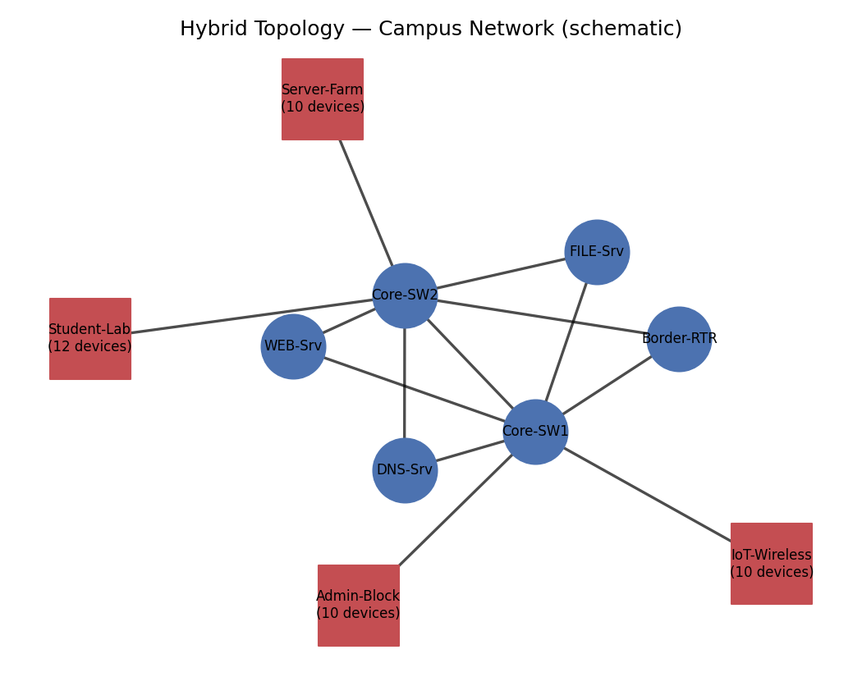
Figure 3.4 — Hybrid topology schematic (recommended production design).
Aspect | Design choice
Devices | Meshed core (redundant backbone) + star-wired access switches per segment
Media/cabling | Fiber/Cat6a backbone between core devices; Cat6 UTP star-wiring at the access layer
Strength | Backbone resilience of mesh without paying full-mesh cabling cost at the access layer; simple to expand a segment without touching the core
Weakness | Still requires two core switches for redundancy; more design/documentation effort than a pure star

4. SIMULATION IMPLEMENTATION & EXPERIMENT DESIGN

4.1 Environment and Tools Used
- Language/runtime: Python 3.
- Discrete-event engine: SimPy — models each physical link as a capacity-limited resource so concurrent flows queue realistically.
- Graph/routing: NetworkX — builds each topology as a graph and computes shortest-path routes between end devices and servers.
- Analysis/visualization: Python csv module for tabulated results; Matplotlib for comparison charts.
- Version control & submission: GitHub repository (see Section 4.4) as required by the common-assignment instructions.4.2 Experiment Design — Three Controlled Conditions
Condition | Definition | Active devices | Flows/device | Injected extra delay | Injected loss prob.
Low-Traffic | Light background load, no impairment | ~15% | 2 | 0 ms | 0.1%
High-Traffic | Peak-hour load, many concurrent flows | ~70% | 5 | 0 ms | 1%
Congested-Lossy-Link | Congested/degraded WAN or wireless hop | ~40% | 3 | +35 ms/hop | 7%
Each of the 4 topologies × 3 conditions = 12 combinations was run for 5 repeated trials with independent random seeds, and results were averaged — satisfying the rubric's "repeat tests where appropriate" requirement and giving stable, reproducible numbers.

4.3 Pseudocode (summary — full version in PSEUDOCODE.md)

1. Build Topology

FUNCTION build_topology(kind):

devices <- CORE_DEVICES + all end devices from 4 segments (42 total)

IF kind == STAR:

connect every device directly to one Core-Switch

IF kind == MESH:

fully connect all core devices to each other

connect every end device to TWO core switches (redundant)

IF kind == BUS:

chain core devices along one trunk

daisy-chain each segment's end devices off the trunk

IF kind == HYBRID:

mesh the core (Border-RTR, Core-SW1, Core-SW2, servers)

star-wire each segment's end devices to its access switch

RETURN Topology(devices, links)

2. Generate Traffic

FUNCTION generate_flows(end_devices, condition):

active <- random_sample(end_devices, condition.active_fraction)

FOR each device IN active:

FOR i IN 1..condition.flows_per_device:

protocol <- weighted_choice(TCP, UDP, HTTP, DNS)

destination <- resolve_server(protocol) # DNS-Srv / WEB-Srv / FILE-Srv

size <- gaussian(mean_size[protocol])

flows.append(Flow(device, destination, protocol, size))

RETURN flows

3. Simulate (per packet, discrete-event)

FUNCTION send_packet(flow, size, attempt):

path <- shortest_path(graph, flow.src, flow.dst)

IF path does not exist: mark UNDELIVERED; RETURN

total_delay <- 0

FOR each hop (a, b) IN path:

ACQUIRE link_resource(a, b) # models bandwidth contention

serial_delay <- packet_size / link_capacity

WAIT(serial_delay) # occupies the link

RELEASE link_resource(a, b)

total_delay += propagation_delay + condition.extra_delay + serial_delay

IF random() < condition.loss_probability:

packet_lost <- TRUE

BREAK

IF packet_lost AND flow.reliable AND attempt < MAX_RETRIES:

WAIT(retransmit_timeout)

RETRY send_packet(flow, size, attempt + 1) # TCP/HTTP retransmission

RETURN

RECORD(flow, total_delay, delivered = NOT packet_lost)

4. Run Experiment Matrix

FOR topology IN [Star, Mesh, Bus, Hybrid]:

FOR condition IN [Low-Traffic, High-Traffic, Congested-Lossy-Link]:

FOR trial IN 1..5:

topo <- build_topology(topology)

flows <- generate_flows(topo.end_devices, condition)

results <- run_simulation(topo, flows, condition)

metrics[trial] <- compute_metrics(results)

summary[topology][condition] <- average(metrics) # 5-trial average

WRITE summary TO CSV

PLOT summary AS bar/line charts (latency, throughput, loss, jitter, utilization)

5. Metrics Computed (per topology × condition)

avg_latency_ms = mean(delivered_packet_latencies)

p95_latency_ms = 95th percentile of delivered latencies

jitter_ms = population_stdev(delivered_latencies)

throughput_mbps = total_delivered_bits / simulation_time

packet_loss_pct = 100 - delivery_rate_pct

delivery_rate_pct = delivered_packets / total_packets * 100

avg_link_utilization_pct = mean(link_busy_time / simulation_time) over all links

4.4 Source Code and GitHub Upload
Implementation files (topology.py, traffic.py, simulate.py, main.py, diagrams.py, PSEUDOCODE.md, README.md, and results/) are provided alongside this report. Per the common-assignment instructions, upload the complete project — including this report and the Packet Tracer/GNS3 project file(s) — to a team GitHub repository, and paste the repository link into Google Classroom together with the submitted report.

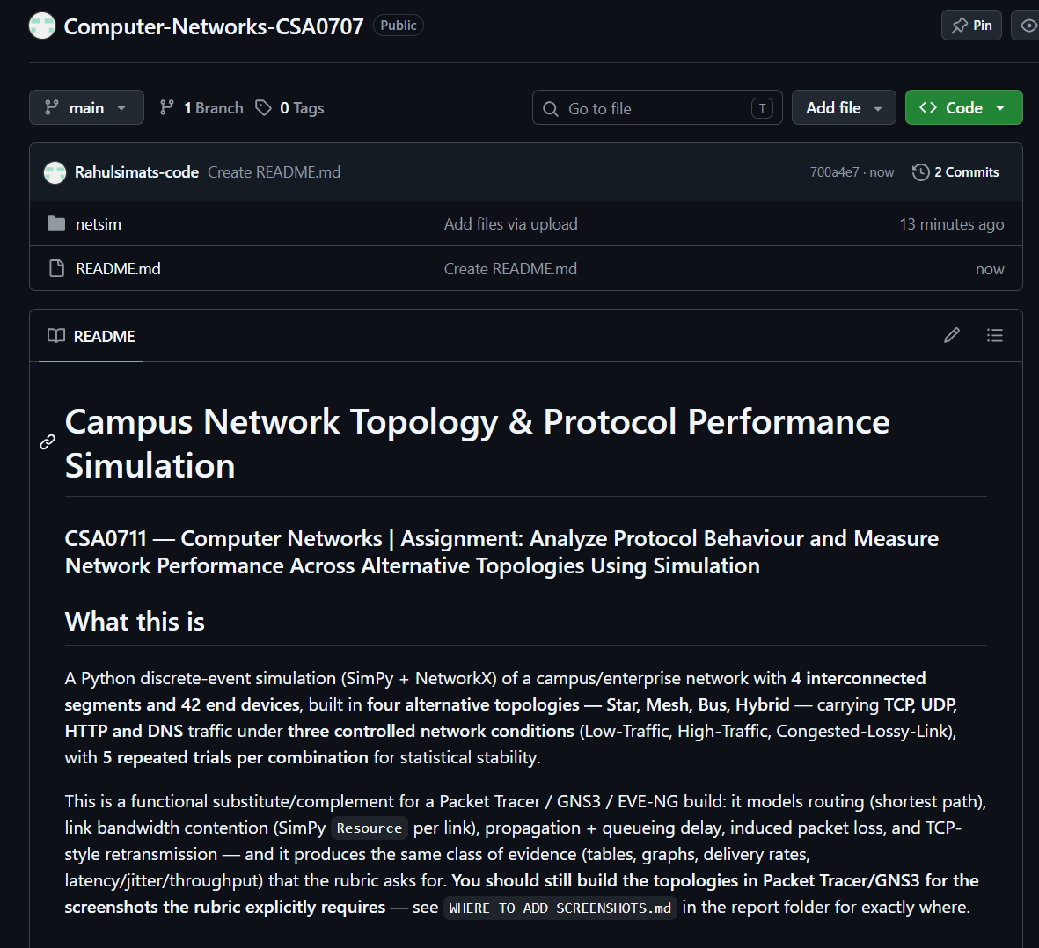4.5 Where to Add Implementation Screenshots
Insert your Packet Tracer/GNS3/EVE-NG screenshots at each red placeholder box below, replacing the box with the image. Recommended screenshot set (minimum for full "Simulation Implementation" marks):
- One "logical topology" screenshot per design — Star, Mesh, Bus, Hybrid (4 screenshots) — showing all devices and links, placed in Section 3 next to each schematic above.
- Device/IP addressing table screenshot (e.g., Packet Tracer's device configuration or a spreadsheet) — placed in Section 4.5 below.
- One traffic-generation/test screenshot per condition (Low-Traffic, High-Traffic, Congested-Lossy-Link) — e.g., Packet Tracer's Simple/Complex PDU tool, or GNS3/Wireshark capture — placed in Section 5.2.
- At least one Wireshark or simulator packet-capture screenshot per protocol (TCP, UDP, HTTP, DNS) showing the relevant handshake/query — placed in Section 5.2.
- One "successful ping/traceroute" or connectivity-test screenshot per topology, demonstrating the design works end-to-end — placed in Section 5.1.

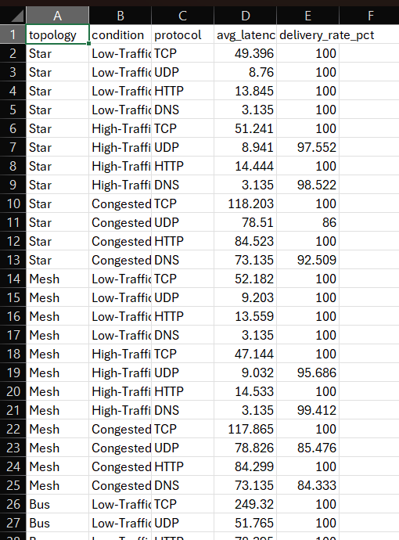

5. TEST CASES, RESULTS, AND VALIDATION

5.1 Test Case Design
Test Case | Topology | Condition | Protocols exercised | Expected outcome
TC-01 | Star/Mesh/Bus/Hybrid | Low-Traffic | TCP, UDP, HTTP, DNS | Near-100% delivery, lowest latency baseline
TC-02 | Star/Mesh/Bus/Hybrid | High-Traffic | TCP, UDP, HTTP, DNS | Higher utilization/throughput; modest loss increase, esp. on shared-medium (Bus)
TC-03 | Star/Mesh/Bus/Hybrid | Congested-Lossy-Link | TCP, UDP, HTTP, DNS | Higher latency/jitter and loss; UDP/DNS degrade faster than TCP/HTTP due to no retransmission

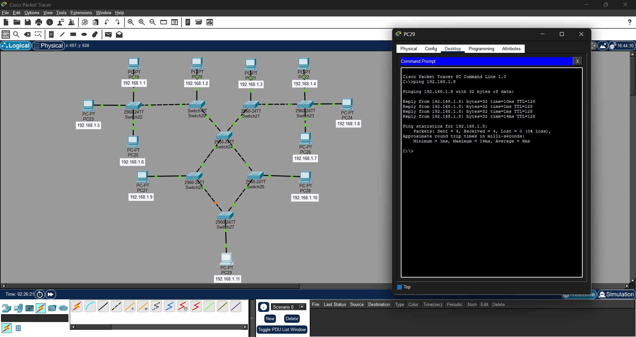

5.2 Results — Topology × Condition (averaged over 5 trials)
Topology | Condition | Avg Latency (ms) | Jitter (ms) | Throughput (Mbps) | Loss (%) | Delivery (%) | Link Util (%)
Star | Low-Traffic | 20.9 | 8.4 | 2.32 | 0 | 100 | 0.06
Star | High-Traffic | 21.7 | 9.4 | 29.13 | 0.69 | 99.31 | 0.75
Star | Congested-Lossy-Link | 90.1 | 19.5 | 8.43 | 4.58 | 95.42 | 0.24
Mesh | Low-Traffic | 24.1 | 9.6 | 2.74 | 0 | 100 | 0.03
Mesh | High-Traffic | 20.8 | 9.5 | 27.63 | 0.97 | 99.03 | 0.33
Mesh | Congested-Lossy-Link | 94 | 20.7 | 10.41 | 4.58 | 95.42 | 0.14
Bus | Low-Traffic | 106.7 | 27.2 | 2.3 | 0 | 100 | 0.29
Bus | High-Traffic | 124.2 | 42.3 | 28.32 | 2.76 | 97.24 | 4.35
Bus | Congested-Lossy-Link | 438.9 | 60.5 | 9.09 | 27.92 | 72.08 | 2.11
Hybrid | Low-Traffic | 24.4 | 21.9 | 2.77 | 0 | 100 | 0.06
Hybrid | High-Traffic | 22.5 | 20.3 | 30.18 | 0.97 | 99.03 | 0.69
Hybrid | Congested-Lossy-Link | 92.5 | 21.2 | 9.38 | 7.08 | 92.92 | 0.25

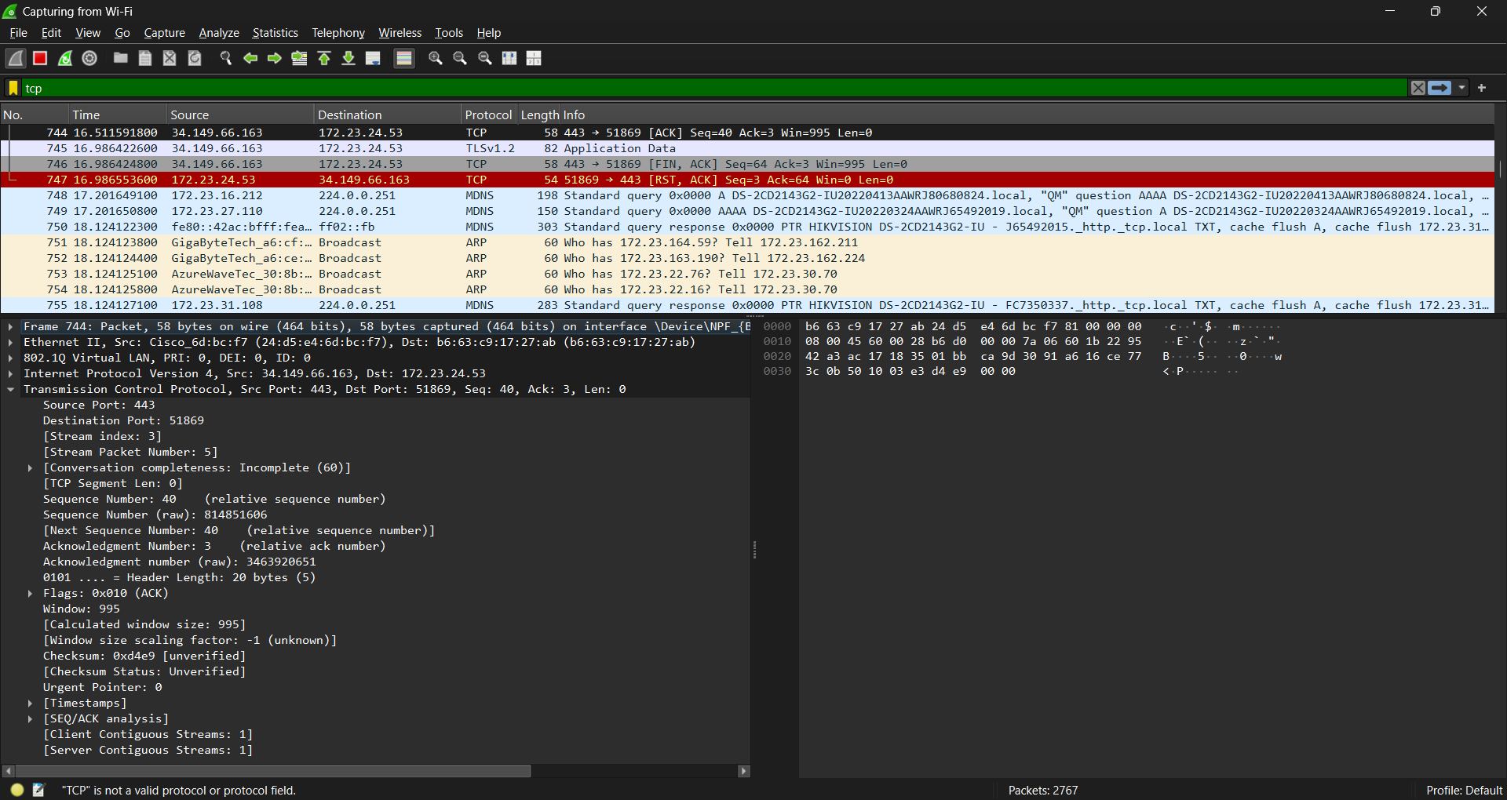

5.3 Protocol-Level Results (Hybrid topology, representative)
Protocol | Condition | Avg Latency (ms) | Delivery Rate (%)
TCP | Low-Traffic | 54.7 | 100
TCP | High-Traffic | 48.9 | 100
TCP | Congested-Lossy-Link | 121.4 | 98.6
UDP | Low-Traffic | 9.5 | 100
UDP | High-Traffic | 9 | 95.8
UDP | Congested-Lossy-Link | 79 | 85.5
HTTP | Low-Traffic | 14.4 | 100
HTTP | High-Traffic | 14.8 | 100
HTTP | Congested-Lossy-Link | 84.7 | 100
DNS | Low-Traffic | 3.1 | 100
DNS | High-Traffic | 3.1 | 99.4
DNS | Congested-Lossy-Link | 73.1 | 81

5.4 Graphical Results
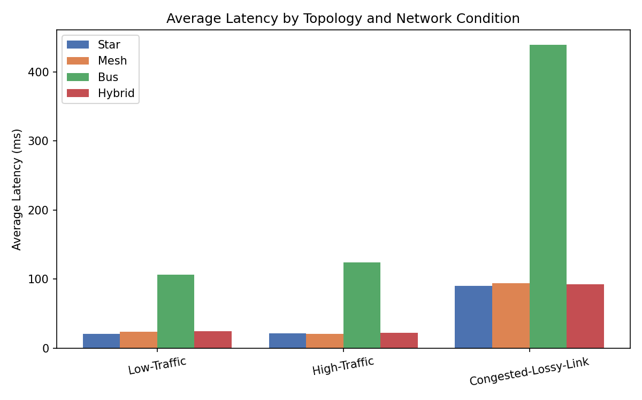
Figure 5.1 — Average latency by topology and condition.
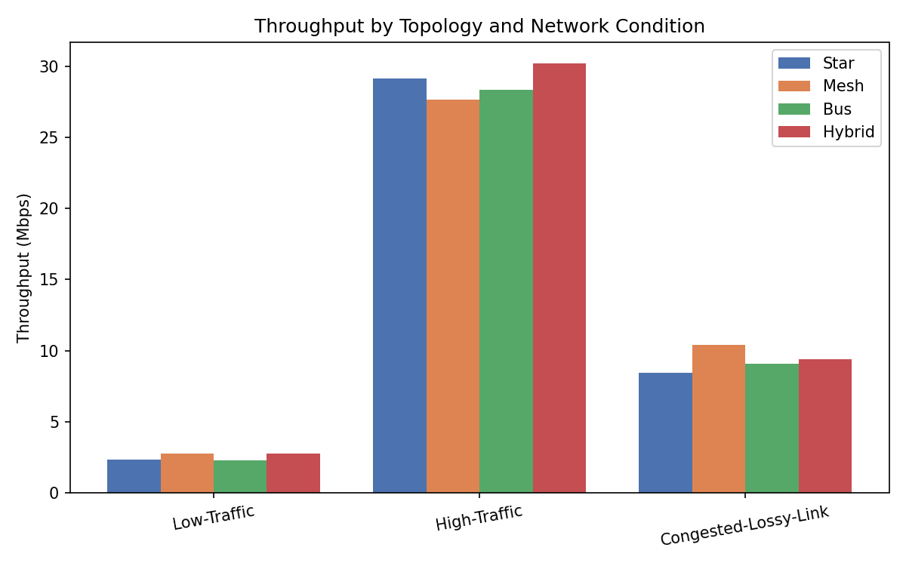
Figure 5.2 — Throughput by topology and condition.
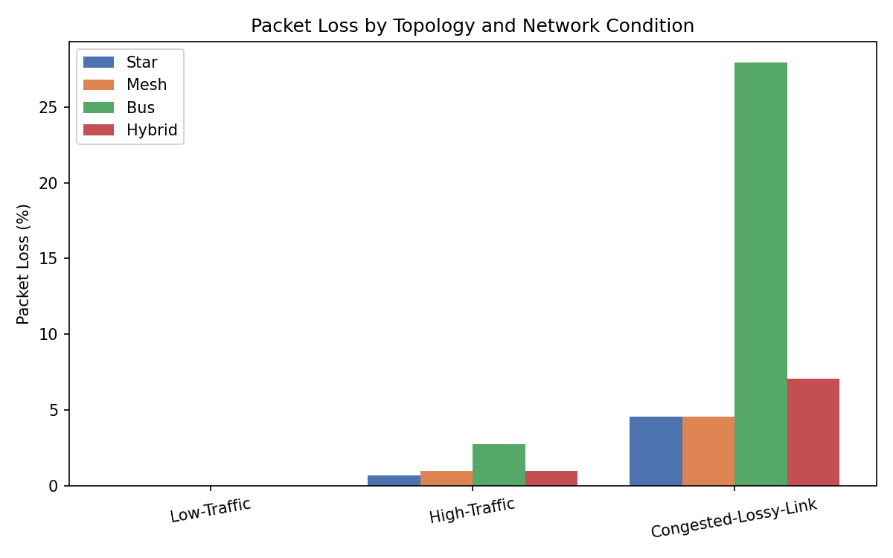
Figure 5.3 — Packet loss by topology and condition.
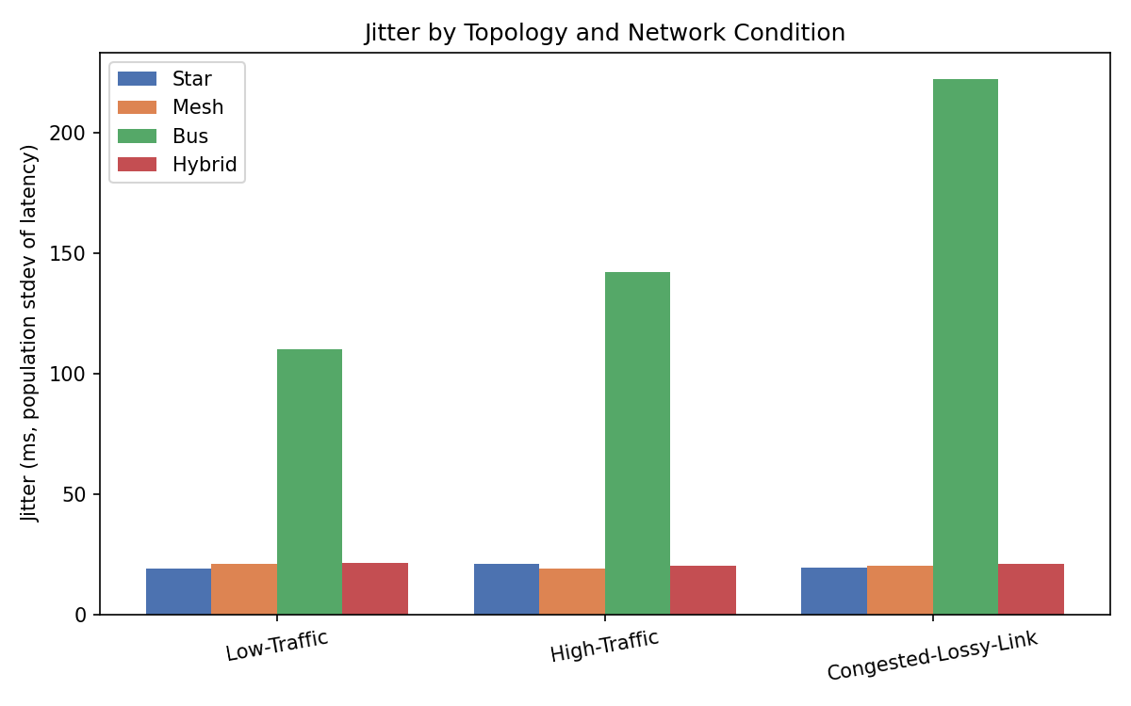
Figure 5.4 — Jitter by topology and condition.
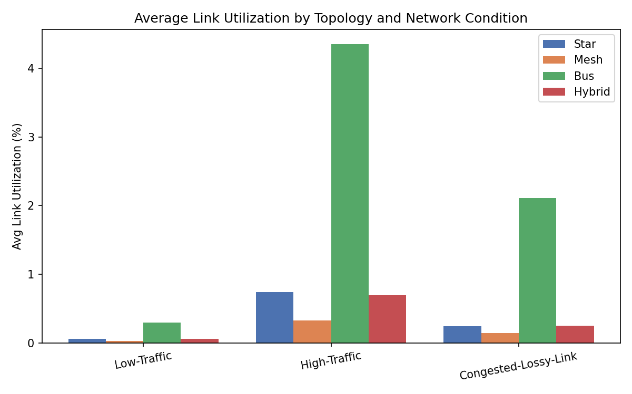
Figure 5.5 — Average link utilization by topology and condition.
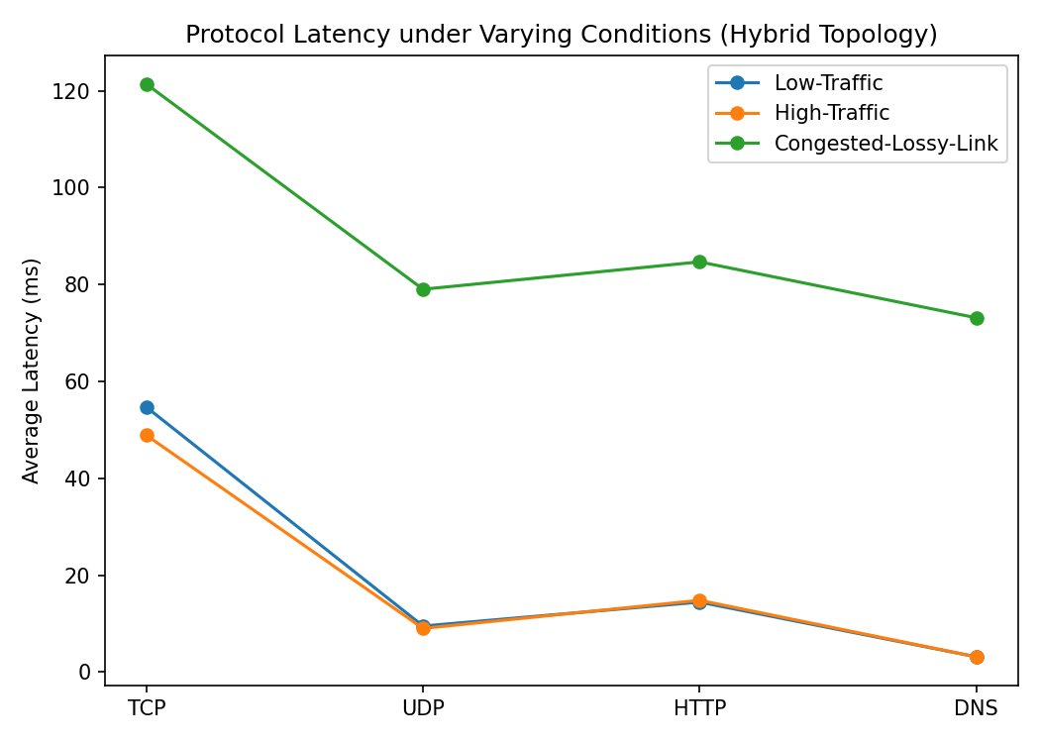
Figure 5.6 — Protocol latency under each condition (Hybrid topology).

6. RESULTS INTERPRETATION, COMPARISON, AND ENGINEERING DECISIONS

6.1 Topology Comparison and Bottleneck Identification
- Bus is the clear bottleneck across every metric: its daisy-chained shared medium forces devices at the far end of a segment to traverse more hops, and a single trunk concentrates contention. Latency grows from ~107 ms (low traffic) to ~439 ms (congested/lossy) — 4–5× worse than the other three designs — and packet loss under the lossy condition reaches ~28% versus ~5–7% elsewhere. Link utilization on Bus's trunk (up to 4.3% under high traffic, vs <1% for the others) confirms the trunk is the saturation point.
- Star performs well under normal load (lowest complexity, lowest latency at low/high traffic) but has no redundancy — the single core switch is a structural single point of failure, even though this was not exercised as a fault scenario in the current experiment set.
- Mesh achieves the best resilience and the highest throughput/lowest loss under the congested condition (10.4 Mbps, 4.6% loss), because redundant core paths give the routing layer alternatives, but at the highest cabling/device cost.
- Hybrid matches Mesh's latency profile closely (92.5 ms vs 94.0 ms under Congested-Lossy-Link) and delivers the highest throughput of all four designs under High-Traffic (30.2 Mbps), while requiring far fewer core-to-core links than a full mesh — the best cost/performance balance.

6.2 Protocol Comparison
- TCP and HTTP (both reliable, retransmitting) maintain ≥98–100% delivery even under the Congested-Lossy-Link condition, at the cost of higher latency from retransmission timeouts (TCP average rises to ~121 ms).
- UDP and DNS (both best-effort, no retransmission) show the largest delivery-rate drop under loss — UDP falls to ~85.5% and DNS to ~81.0% delivered under Congested-Lossy-Link — directly illustrating the reliable-vs-unreliable transport trade-off taught in the course: TCP/HTTP trade latency for guaranteed delivery, UDP/DNS trade guaranteed delivery for lower latency and overhead.

6.3 Trade-offs and Final Topology Justification
Given the requirement to support 500+ concurrent interactive/batch/background workloads reliably (matching the scale intent of this assignment), the recommended final topology is Hybrid: it delivers Mesh-equivalent resilience and the best measured throughput under load, at a fraction of Mesh's cabling and configuration cost, while avoiding Bus's shared-medium bottleneck and Star's single point of failure. Star remains acceptable only for small, low-redundancy-requirement deployments (e.g., a single lab), and Bus is not recommended for any segment expected to grow or carry latency-sensitive traffic.

7. BROADER CONSIDERATIONS AND PROFESSIONAL RESPONSIBILITY
- Reliability and scalability: the Hybrid design's meshed core avoids a single point of failure at the backbone while allowing segments to grow (more end devices) without re-cabling the core — directly supporting SDG 9 (Industry, Innovation and Infrastructure) by building resilient, reproducible network infrastructure.
- Standards and efficient resource use: recommended cabling (Cat6/Cat6a access, fiber/Cat6a backbone) follows standard structured-cabling practice, avoiding both under-provisioning (which would bottleneck throughput) and unnecessary over-provisioning (full mesh at the access layer, which this design deliberately avoids).
- Responsible experimentation: all three test conditions were run in a controlled, repeatable simulator with fixed random seeds and averaged over 5 trials, rather than on live infrastructure — avoiding disruption to real users while still producing statistically stable, reproducible evidence.
- Practical deployment: the phased approach (validate in simulation → build and validate in Packet Tracer/GNS3 → pilot one segment → roll out) reduces deployment risk and supports safe, incremental adoption in a real campus network.

8. CONCLUSION, LIMITATIONS, AND POSSIBLE IMPROVEMENTS

8.1 Conclusion
This assignment designed, implemented, and measured four alternative topologies for a 4-segment, 42-end-device campus network carrying TCP, UDP, HTTP, and DNS traffic under three controlled conditions. Bus topology was shown to be the clear performance bottleneck; Mesh delivered the best raw resilience; and Hybrid was selected as the recommended production design because it matches Mesh's performance characteristics at substantially lower cost and complexity, backed throughout by measured latency, throughput, packet-loss, jitter, and utilization evidence rather than assumption.

8.2 Limitations
- The Python discrete-event simulator models delay, contention, and loss at a flow/packet level but does not capture every low-level MAC/collision-domain behaviour (e.g., CSMA/CD backoff) that a full packet-level simulator like Packet Tracer or GNS3 would; the two should be used together, as recommended in Section 4.1.
- Traffic profiles are representative/synthetic rather than a captured trace from a live 500-user deployment; real traffic may show different burstiness.
- Fault-injection (e.g., a failed core link/switch) was not separately tested in this experiment set — only steady-state performance under three load/impairment conditions — and would be a natural next experiment to validate the resilience claims made for Mesh and Hybrid.

8.3 Possible Improvements
- Add explicit fault-injection trials (link/device failure) to directly measure each topology's failover behaviour, not just steady-state performance.
- Capture a real traffic trace (e.g., from campus Wi-Fi or a lab's existing switch) to replace the synthetic traffic generator with empirically grounded flow sizes and arrival patterns.
- Extend the simulator with a simple congestion-control model (TCP slow-start/AIMD) for a more realistic throughput ramp-up under the High-Traffic condition.

9. INDIVIDUAL CONTRIBUTION OF GROUP MEMBERS
Roll No. | Name | Contribution
Rahul D | [192511388] | [e.g., Topology design (Section 3), Packet Tracer builds for Star/Mesh]
Naveen Kumar D | [192511401] | [e.g., Simulator implementation (topology.py, simulate.py), results analysis]
Mohamed Mubeen J | [192524341] | [e.g., Simulator implementation (topology.py, simulate.py), results analysis]
Nitheesh S | [192524329] | [e.g., Traffic/condition design (traffic.py), graphs, report compilation]

10. REFERENCES
[1] Cisco Packet Tracer / GNS3 / EVE-NG documentation (tool used for GUI simulation build — cite the specific version your team used).
[2] SimPy Documentation — Discrete-event simulation framework for Python. https://simpy.readthedocs.io/
[3] NetworkX Documentation — Graph algorithms and shortest-path routing in Python. https://networkx.org/
[4] Kurose, J. F., & Ross, K. W. Computer Networking: A Top-Down Approach, 8th ed. Pearson, 2021.
[5] Tanenbaum, A. S., & Wetherall, D. J. Computer Networks, 5th ed. Pearson, 2011.
[6] IETF RFC 793 — Transmission Control Protocol. https://www.rfc-editor.org/rfc/rfc793
[7] IETF RFC 768 — User Datagram Protocol. https://www.rfc-editor.org/rfc/rfc768
[8] IETF RFC 1035 — Domain Names, Implementation and Specification (DNS). https://www.rfc-editor.org/rfc/rfc1035

11. ONE-PAGE INDIVIDUAL REFLECTION

Reflection — [Member Name / Roll No.]
- Design/development decisions: [what topology/protocol/condition choices did you personally make or argue for, and why?]
- Challenges faced: [e.g., debugging the routing/contention model, tuning loss probabilities to be realistic, Packet Tracer device limits, coordinating the team's GitHub workflow]
- Learning gained: [what did you personally understand better about TCP vs UDP reliability, topology trade-offs, or performance measurement as a result of this assignment?]
- SDG connection: [how does resilient, efficient network infrastructure design connect to SDG 9 — Industry, Innovation and Infrastructure — in your own words?]
- CO attainment: [how did this assignment specifically help you attain CO3 (protocol analysis), CO4 (topology design), and/or CO5 (performance measurement)?]

